Tips for Interns
WELCOME

PACK
2011

Dear future Intern,

Welcome to France

We would like to welcome you to France. During your internship you will experience both life in one of the biggest cities in the world and what it is like to work within an important company.

We realise that moving to a different country can be a daunting experience, but this brief Tips for Interns is designed to answer any questions that you may have before your arrival in France.

Paris

Paris itself is divided into 20 areas called “arrondissements”, arranged in a spiral fashion, surrounded by “banlieues” (suburbs).

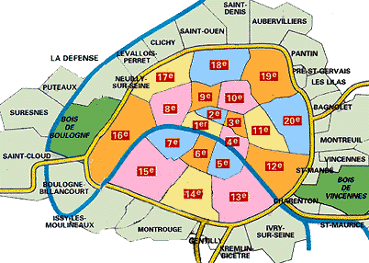

Accommodation

It is recommend that you come out to Paris before your internship in order to sort out accommodation, which can be difficult to find in Paris. However, although it is traditionally easier to sort out accommodation while you are in France, we realise that coming in-advance might not be possible for everyone.

There are two options when choosing accommodation in Paris; in the city-centre (within one of the 20 arrondissements) or in the banlieues. Although the suburbs are traditionally cheaper than the city-centre, the majority of interns live in the city for the atmosphere and convenience of city-centre life.

Choosing a location for your accommodation depends largely on where you are working. For the north suburb of the city , you will probably want to choose somewhere in close proximity to a stop on the RER B line (for example Port Royal, Luxembourg, St.Michel-Notre Dame, Châtelet-Les Halles, Gare du Nord). For the south side, perhaps somewhere along the RER C line (for example Champ de Mars-Tour Eiffel, Musée d’Orsay, St.Michel-Notre Dame, Gare d’Austerlitz, Bibliothèque François Mitterand). Bear in mind that the further away you live from one of these stations, the longer it will take you to commute to work in the morning.

We can recommend the following sites, either from personal experience or from what we’ve been told by others:

- Lodgis (www.lodgis.com). Rental agency located in Paris, which offers properties within the city-centre. Website is in English and includes both pictures and the option to search by arrondissement. They employ English-speaking agents too, but be warned that they do charge agency fees on top of any rental charges.

- The American Church near to the Eiffel Tower has a notice board with lots of adverts for housing. It is located at 65, Quai d’Orsay in the 7th arrondissement.

- FUSAC (www.fusac.fr). FUSAC is a free magazine for Anglophones who live in Paris, which is now available on the internet. Amongst other things, there are offers for flat-sharing and rentals. If you happen to be in Paris, the magazine itself is available from many Irish and English pubs dotted around the city and is released every fortnight on a Thursday.

- De Particulier à Particulier (www.pap.fr). A French magazine that operates in a very similar way to FUSAC but on a larger scale. The magazine is available from most French newsagents. The website also includes advice on how to rent in France.

- Craig’s List (www.craigslist.org). Internet-only advertisement site, which includes opportunities for rentals, house-sharing and subletting. Be aware of hoaxes on this site and do not part with any money until you have seen the accommodation. Recommended more to people who have the chance to travel to France.

- Paris Attitude (www.parisattitude.com). Very similar to Lodgis in its layout. Again, be aware that agency fees will be charged. But guarantee the standard of the accommodation and the legalities of the rental.

Transport

As with any major city, Paris’ public transport system is both huge and may appear a little complicated. There are two main rail links, the Metro and the RER. In general, the metro operates within the city-centre, i.e. the 20 arrondissements, while the RER stretches into the suburbs and beyond. A monthly travel card can be purchased and maintained monthly. Below is a map of the RER routes:

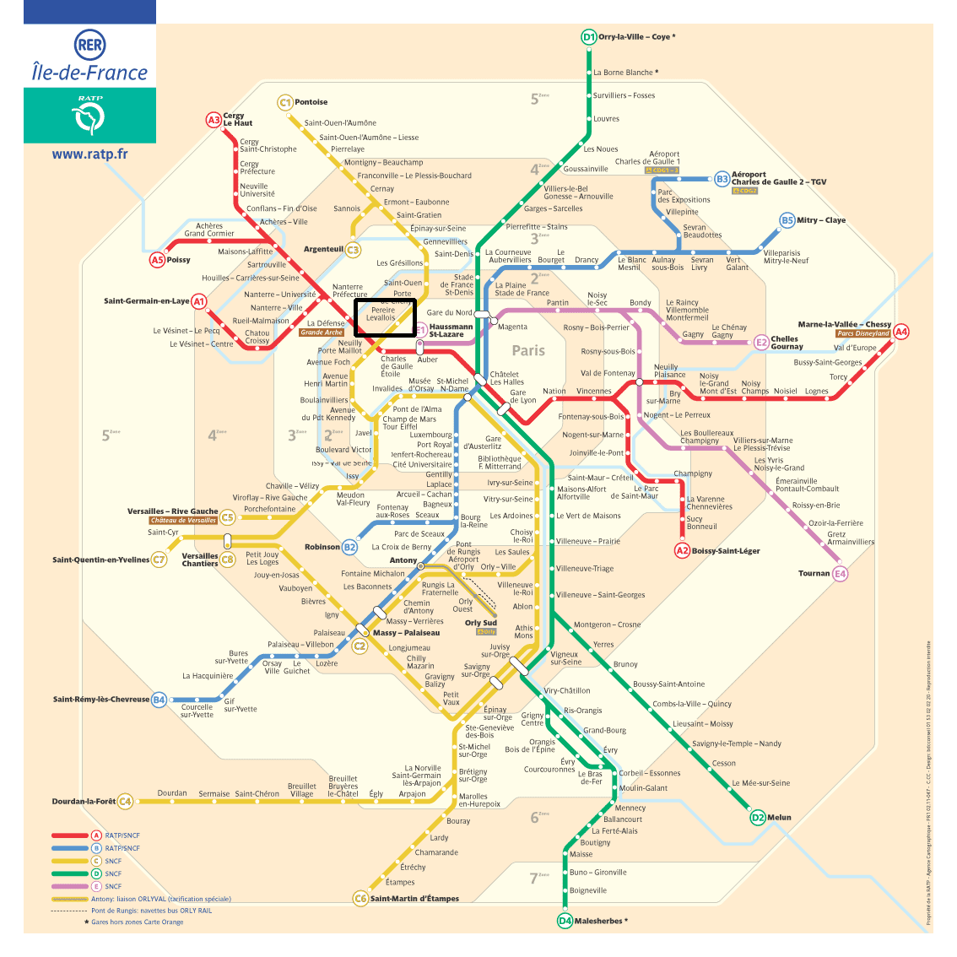

Both airports are within the outer zones of the RER map (Orly zone 4, Roissy zone 5). Since ticket prices vary according to zone, it is important to buy the right ticket.

The Parisian public transport system uses the Navigo pass, which is similar in concept to London’s Oyster Card scheme. The pass itself can be obtained free of charge, either online (www.navigo.fr) or at specific, usually main, train stations around Paris, for example Châtelet and Gare du Nord, a list of which can be downloaded in PDF format from the website. To obtain the pass in person, you must normally provide a pièce d’identité (a passport in most cases) a photo and a copy of your rental contract.

The card must then be topped-up at a Navigo machine by credit or debit card. Top-up machines can be found in almost every metro station in Paris. Be careful to choose the right zones according to where you are working.

Bank Account

All interns will need a French bank account in order to be paid. French banks are complicated, especially with foreign customers. The POST OFFICE (Bureau de Poste) is easier. If possible, try to organise a bank account before you start work since it is more difficult to sort anything out outside normal working hours.

In terms of documentation, different banks require different things. To be safe, it’s probably best to try to have all of the following:

- Passport (Pièce d’identité)
- Proof of addresse Attestation de lôgement (normally available from your landlord or agency).
- Rental contract (Bail).
- Work contract

- Or Either - an EDF (Electricité de France) bill in your own name or
- an EDF bill in the name of your landlord and a copy of his/her pièce d’identité.

Don’t be disheartened if banks turn you away; it’s normal. It’s also advisable to make an appointment rather than to walk in and expect to be able to see someone straight away.

Mobile Phone

Mobile phones have become an indispensable part of everyday life, and you probably won’t want to go without one during your time in France. There are mobile phone shops everywhere in Paris and a pay-as-you-go sim card is easily available for your current phone, while phones with sim included cost as little as €30.

Your First Day

We all know how impressive it is to start a new job, particularly in a different country. In terms of a dress-code, we would recommend smart-casual; no need for a suit and tie, avoid shorts and mini-skirts.

Traditionally, in France, when you first come into the office, not only on your first day but on every day you are at work, you must say “Bonjour” to everyone you meet for the first time on that day, but only say it once a day to each person. The same applies for “Au revoir” when you leave at the end of the day.

It is also important to know how to address people within the workplace. As a general rule, unless somebody permits you to do otherwise, use the vous form of the verb to address either a colleague or a student coming into the centre.

Contacts

There are probably many more questions that you want to ask before you start work. Feel free to contact us at any stage.

